ORDER YOUR CULINARY ARTIST

A Major Project Report Submitted
In partial fulfillment of the requirements for the award of the degree of

Bachelor of Technology
in
Computer Science and Engineering

by

Grandhe Eshwara Sai Anirudh 17N31A0573

Gunda Vyshnavi 17N31A0577
Gundreddy Sahith Reddy 17N31A0578

Gouru Srinivas 18N35A0507

Under the esteemed guidance of

W. NIRMALA
Assistant Professor



Department of Computer Science and Engineering
Malla Reddy College of Engineering & Technology
(Autonomous Institution- UGC, Govt. of India)
(Affiliated to JNTUH, Hyderabad, Approved by AICTE, NBA &NAAC with ‘A’ Grade)
Maisammaguda, Kompally, Dhulapally, Secunderabad – 500100
website: www.mrcet.ac.in
2017-2021
Malla Reddy College of Engineering & Technology
(Autonomous Institution- UGC, Govt. of India)
(Affiliated to JNTUH, Hyderabad, Approved by AICTE, NBA &NAAC with ‘A’ Grade)
Maisammaguda, Kompally, Dhulapally, Secunderabad – 500100
website: www.mrcet.ac.in

CERTIFICATE

This is to certify that this is the bonafide record of the project entitled “Order Your Culinary Artist”, submitted by Grandhe Eshwara Sai Anirudh (17N31A0573), Gunda Vyshnavi (17N31A0577), Gundreddy Sahith Reddy (17N31A0578) and Gouru Srinivas (18N35A0507) of B.Tech in the partial fulfillment of the requirements for the degree of Bachelor of Technology in Computer Science and Engineering, Department of CSE during the year 2020-2021. The results embodied in this project report have not been submitted to any other university or institute for the award of any degree or diploma.

Internal Guide Project Coordinator
W. Nirmala Dr. S Shanthi
Assistant Professor Professor

Head of the Department External Examiner
Dr. T. Venugopal
Professor

ABSTRACT
This is a service-oriented web application where people can book a chef, and chefs services are provided accordingly, developed using Node.js, MongoDB and Express.js. Customer can enjoy a customized culinary experience with a Private Chef - all in the comfort of your own home.

A few hours prior to your private dining experience, your personal chef will arrive and begin preparing the menu agreed upon. Watch and learn new recipes from your chef as he cooks in your home kitchen. With our discreet and professional service. We guarantee customers can enjoy with nothing to worry about.

DECLARATION

We hereby declare that the project titled Order Your Culinary Artist submitted to Malla Reddy College of Engineering and Technology (UGC Autonomous), affiliated to Jawaharlal Nehru Technological University Hyderabad (JNTUH) for the award of the degree of Bachelor of Technology in Computer Science and Engineering is a result of original research carried-out in this thesis. It is further declared that the project report or any part thereof has not been previously submitted to any University or Institute for the award of degree or diploma.

Grandhe Eshwara Sai Anirudh - 17N31A0573
Gunda Vyshnavi - 17N31A0577
Gundreddy Sahith Reddy - 17N31A0578
Gouru Srinivas - 18N35A0507

ACKNOWLEDGEMENT

We feel ourselves honored and privileged to place our warm salutation to our college Malla Reddy College of Engineering and Technology (UGC-Autonomous) and our principal Dr. SS Rao, Director Dr. V.S.K reddy who gave us the opportunity to have experience in engineering and profound technical knowledge.

We express our heartiest thanks to our Head of the Department Dr. T. Venugopal for encouraging us in every aspect of our project and helping us realize our full potential.

We would like to thank our Internal guide W. Nirmala and Project Coordinator Dr. S Shanthi for her regular guidance and constant encouragement. We are extremely grateful to her valuable suggestions and unflinching co-operation throughout project work.

We would like to thank our class in charge Mr. Dr. M. Jayapal who in spite of being busy with his duties took time to guide and keep us on the correct path.

We would also like to thank all the supporting staff of the Department of CSE and all other departments who have been helpful directly or indirectly in making our project a success.

We are extremely grateful to our parents for their blessings and prayers for the completion of our project that gave us strength to do our project.

with regards and gratitude

Grandhe Eshwara Sai Anirudh - 17N31A0573

Gunda Vyshnavi - 17N31A0577
Gundreddy Sahith Reddy - 17N31A0578

Gouru Srinivas - 18N35A0507

TABLE OF CONTENTS

S.NO | TITTLE | PG.NO
1 | INTRODUCTION  1.1 PURPOSE, AIM AND OBJECTIVES  1.2 BACKGROUND OF PROJECT  1.3 SCOPE OF PROJECT  1.4 MODULES DESCRIPTION | 01  01  01  01  02
2 | SYSTEM ANALYSIS  2.1 HARDWARE AND SOFTWARE REQUIREMENTS  2.2 SOFTWARE REQUIREMENTS SPECIFICATION | 03  03  03
3 | TECHNOLOGIES USED  3.1 HTML  3.2 CSS  3.3 NODE.JS  3.4 MONGODB  3.5 EXPRESS.JS  3.6 WEB BROWSER | 06  06  06  06  07  07  07
4 | SYSTEM DESIGN & UML DIAGRAMS  4.1 ARCHITECTURE  4.2 UNIFIED MODELING LANGUAGE | 08  08  08
5 | IMPLEMENTATION | 14
6 | TESTING  6.1 TESTING OBJECTIVES  6.2 TESTING METHODOLOGIES  6.3 USER TRAINING  6.4 MAINTAINENCE  6.5 TESTING STRATEGY  6.6 TEST CASES | 16  16  16  18  19  19  21
7 | OUTPUT SCREENS | 30
8 | CONCLUSION & FUTURE SCOPE | 34
9 | BIBLIOGRAPHY | 35

1. INTRODUCTION
This chapter gives an overview about the purpose, aim, objectives, background and operation environment of the system.

  - PURPOSE, AIM AND OBJECTIVES:

It is an on-demand cook booking web app to prepare your favourite food at your place

- This application is effective, efficient and initiating for helping users.
- This cook booking Application will provide general help features like emergency buttons helpful in case of unexpected situations.
- It provides features like Sending email when a user registers into the app and ordering, canceling the chef in no time.
- This Application has an admin module through which the chef gets registered into the app only after background verification this makes the web app safer to the user.
- It permits the user to get the chef’s contact details and other basic information like name, email id etc.

1.2 BACKGROUND OF PROJECT:

The current project aims to provide best hospitality of a chef to the user at the comfort of your home. It is a healthier alternative to online ordering. Though online ordering might be convenient, but hygiene and health always remain a big issue. Even chances are that you might not even get the food you crave. With our application you can get to book a chef who will make your favorite dish in your kitchen.

SCOPE OF PROJECT:

Chef coming to our home or said place along with ingredients where we need not to travel to the place, under our surveillance, hygienic, with freedom and pay moderate cost for food.
Billing is done through communication between the user and chef by the provided chef details to the user.

1.4 MODULES DESCRIPTION:

This project is composed of three main modules:

1. User module: In this module we have all the features related to the user like:
1. User signup: By using this user can register to our application.
2. User login: By using this user can login to our application with registered details.
3. Show chefs: By using this feature user can see all the chef’s available
4. Cancel chef: By using this feature user can cancel a chef he/she ordered
5. My requests: By using user can see the details of the chef whom he/she ordered
6. Emergency: This feature has emergency contact details of the chef
7. Delete my account: A user can delete the account by using this feature

2. Chef’s Module: In this module we have all the features related to the chef
1. Set not Available: By using feature chef can set himself as not available so therefore he/she cannot get any orders until available.
2. Set available: The chef can set available once he /she becomes available to take the
orders.
3. Chef login: chef can login into the app using registered details from admin.
4. Chef requests: Chef can see all his recent requests.
5. Emergency: This feature has emergency contact details of the user.

3. Admin module: In this module we have all the features related to the chef which needs authentication
1. Chef register: By using this chef can register to our application but will be registered
only after authentication by the admin.
2. Delete chef: Only an admin can delete a chef
3. View all recent orders: admin can see all the recent orders of all the chefs
4. View all chefs: admin can see all the chefs through this feature

2. SYSTEM ANALYSIS
In this chapter, we will discuss and analyze about the developing process of Audit Control including software requirement specification (SRS) and comparison between existing and proposed system. The functional and non-functional requirements are included in SRS part to provide complete description and overview of system requirement before the developing process is carried out. Besides that, existing vs. proposed provides a view of how the proposed system will be more efficient than the existing one.

2.1 HARDWARE AND SOFTWARE REQUIREMENTS

2.1.1 HARDWARE REQUIREMENTS:

Processor : Intel core I3.
Ram : 4 GB or above.
Hard disk : 500GB or above.

2.1.2 SOFTWARE REQUIREMENTS:

Technology/Language : HTML5, CSS3, EXPRESSJS, NPM
Data Base : MONGODB.
Operating System : Windows 8 or later.
Browser : Any web browser

2.2 SOFTWARE REQUIREMENT SPECIFICATION:

2.2.1 SRS:

Software Requirement Specification (SRS) is the starting point of the software developing activity. As system grew more complex it became evident that the goal of the entire system cannot be easily comprehended. Hence the need for the requirement phase arose. The software project is initiated by the client needs. The SRS is the means of translating the ideas of the minds of clients (the input) into a formal document (the output of the requirement phase.)
The SRS phase consists of two basic activities:

- Problem/Requirement Analysis:
The process is order and more nebulous of the two, deals with understand the problem, the goal and constraints.
- Requirement Specification:
Here, the focus is on specifying what has been found giving analysis such as representation, specification languages and tools, and checking the specifications are addressed during this activity.
The Requirement phase terminates with the production of the validate SRS document. Producing the SRS document is the basic goal of this phase.

2.2.2 ROLE OF SRS:

The purpose of the Software Requirement Specification is to reduce the communication gap between the clients and the developers. Software Requirement Specification is the medium through which the client and user needs are accurately specified. It forms the basis of software development. A good SRS should satisfy all the parties involved in the system.

2.2.3 SCOPE:

This document is the only one that describes the requirements of the system. It is meant for the use by the developers, and will also be the basis for validating the final delivered system. Any changes made to the requirements in the future will have to go through a formal change approval process. The developer is responsible for asking for clarifications, where necessary, and will not make any alterations without the permission of the client.

2.2.4 EXISTING SYSTEM:

Going to restaurant or hotel to enjoy chef’s food where we need to travel to the place, not under our surveillance, sometimes unhygienic, with constricted, less freedom and pay high cost for food.

2.2.4.1 DRAWBACKS OF EXISTING SYSTEM:

- Unhygienic food
- Increase in expenses due to travelling.
- Even there is a possibility that the food we get is not that you crave when it is delivered finally.

2.2.5 PROPOSED SYSTEM:

Chef coming to our home or said place along with ingredients where we need not to travel to the place, under our surveillance, hygienic, with freedom and pay moderate cost for food.

Billing is done through communication between the user and chef by the provided chef details to the user.

3. TECHNOLOGIES USED

3.1 HTML
HTML (Hyper Text Markup Language) is the most basic building block of the Web. It defines the meaning and structure of web content. Other technologies besides HTML are generally used to describe a web page's appearance/presentation (CSS) or functionality/behavior (JavaScript).

"Hypertext" refers to links that connect web pages to one another, either within a single website or between websites. Links are a fundamental aspect of the Web. By uploading content to the Internet and linking it to pages created by other people, you become an active participant in the World Wide Web.

HTML uses "markup" to annotate text, images, and other content for display in a Web browser. HTML markup includes special "elements" such as <head>, <title>, <body>, <header>, <footer>, <article>, <section>, <p>, <div>, <span>, <img>, <aside>, <audio>, <canvas>, <datalist>, <details>, <embed>, <nav>, <output>, <progress>, <video>, <ul>, <ol>, <li> and many others.

3.2 CSS
Cascading Style Sheets (CSS) is a style-sheet language used to describe the presentation of a document written in HTML or XML (including XML dialects such as SVG, MathML or XHTML). CSS describes how elements should be rendered on screen, on paper, in speech, or on other media.

CSS is among the core languages of the open web and is standardized across Web browsers according to W3C specifications. Previously, development of various parts of CSS specification was done synchronously, which allowed versioning of the latest recommendations. You might have heard about CSS1, CSS2.1, CSS3. However, CSS4 has never become an official version.

From CSS3, the scope of the specification increased significantly and the progress on different CSS modules started to differ so much, that it became more effective to develop and release recommendations separately per module. Instead of versioning the CSS specification, W3C now periodically takes a snapshot of the latest stable state of the CSS specification.

3.3 NODE.JS
Node.js is an open-source and cross-platform JavaScript runtime environment. It is a popular tool for almost any kind of project!

Node.js runs the V8 JavaScript engine, the core of Google Chrome, outside of the browser. This allows Node.js to be very performant.

A Node.js app runs in a single process, without creating a new thread for every request. Node.js provides a set of asynchronous I/O primitives in its standard library that prevent JavaScript code from blocking and generally, libraries in Node.js are written using non-blocking paradigms, making blocking behavior the exception rather than the norm.

When Node.js performs an I/O operation, like reading from the network, accessing a database or the file system, instead of blocking the thread and wasting CPU cycles waiting, Node.js will resume the operations when the response comes back.

This allows Node.js to handle thousands of concurrent connections with a single server without introducing the burden of managing thread concurrency, which could be a significant source of bugs.

Node.js has a unique advantage because millions of frontend developers that write JavaScript for the browser are now able to write the server-side code in addition to the client-side code without the need to learn a completely different language.

3.4 EXPRESS.JS

Express is a popular unopinionated web framework, written in JavaScript and hosted within the Node.js runtime environment. This module explains some of the key benefits of the framework, how to set up your development environment and how to perform common web development and deployment tasks.

3.5 MONGODB

MongoDB is a source-available cross-platform document-oriented database program. Classified as a NoSQL database program, MongoDB uses JSON-like documents with optional schemas. MongoDB is developed by MongoDB Inc. and licensed under the Server Side Public License.

3.6 WEB BROWSER

A web browser is application software for accessing the World Wide Web. When a user requests a web page from a particular website, the web browser retrieves the necessary content from a web server and then displays the page on the user's device.

4. SYSTEM DESIGN & UML DIAGRAMS

4.1 ARCHITECTURE:

MODEL VIEW CONTROLLER
- Model: Model represents the shape of the data. Model objects store data retrieved from the database.
- View: View in MVC is a user interface. View display model data to the user and also enables them to modify them. Ex View in ASP.NET MVC is HTML, CSS, and some special syntax (Razor syntax) that makes it easy to communicate with the model and the controller.
- Controller: The controller handles the user request. Typically, the user uses the view and raises an HTTP request, which will be handled by the controller. The controller processes the request and returns the appropriate view as a response.

4.2 UNIFIED MODELING LANGUAGE (UML):

The unified modeling is a standard language for specifying, visualizing, constructing and documenting the system and its components is a graphical language which provides a vocabulary and set of semantics and rules. The UML focuses on the conceptual and physical representation of the system. It captures the decisions and understandings about systems that must be constructed. It is used to understand, design, configure and control information about the systems.
Depending on the development culture, some of these artifacts are treated more or less formally than others. Such artifacts are not only the deliverables of a project; they are also critical in controlling, measuring, and communicating about a system during its development and after its deployment.
The UML addresses the documentation of a system's architecture and all of its details. The UML also provides a language for expressing requirements and for tests. Finally, the UML provides a language for modeling the activities of project planning and release management.

4.3 UML DIAGRAMS:

4.3.1 CLASS DIAGRAM:
A class is a representation of an object and, in many ways; it is simply a template from which objects are created. Classes form the main building blocks of an object-oriented application.
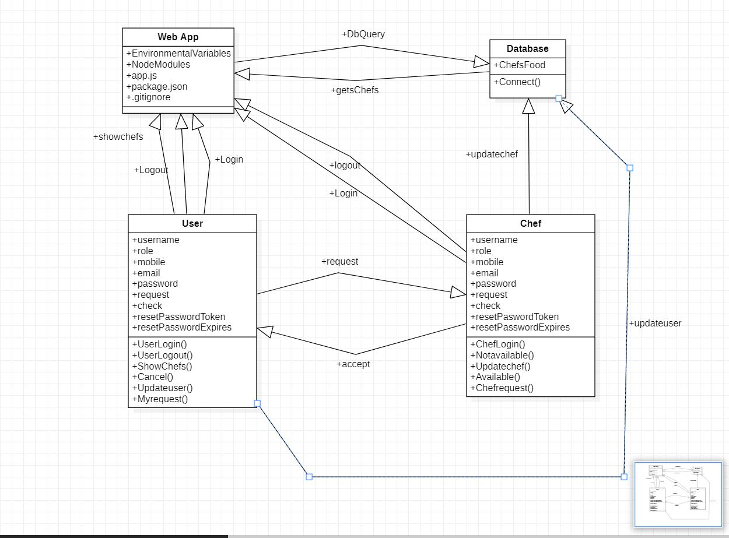

FIGURE 4.3.1: CLASS DIAGRAM

4.3.2 USE CASE DIAGRAM:

A use case diagram is a graph of actors set of use cases enclosed by a system boundary, communication associations between the actors and users and generalization among use cases. The use case model defines the outside (actors) and inside (use case) of the system’s behavior.
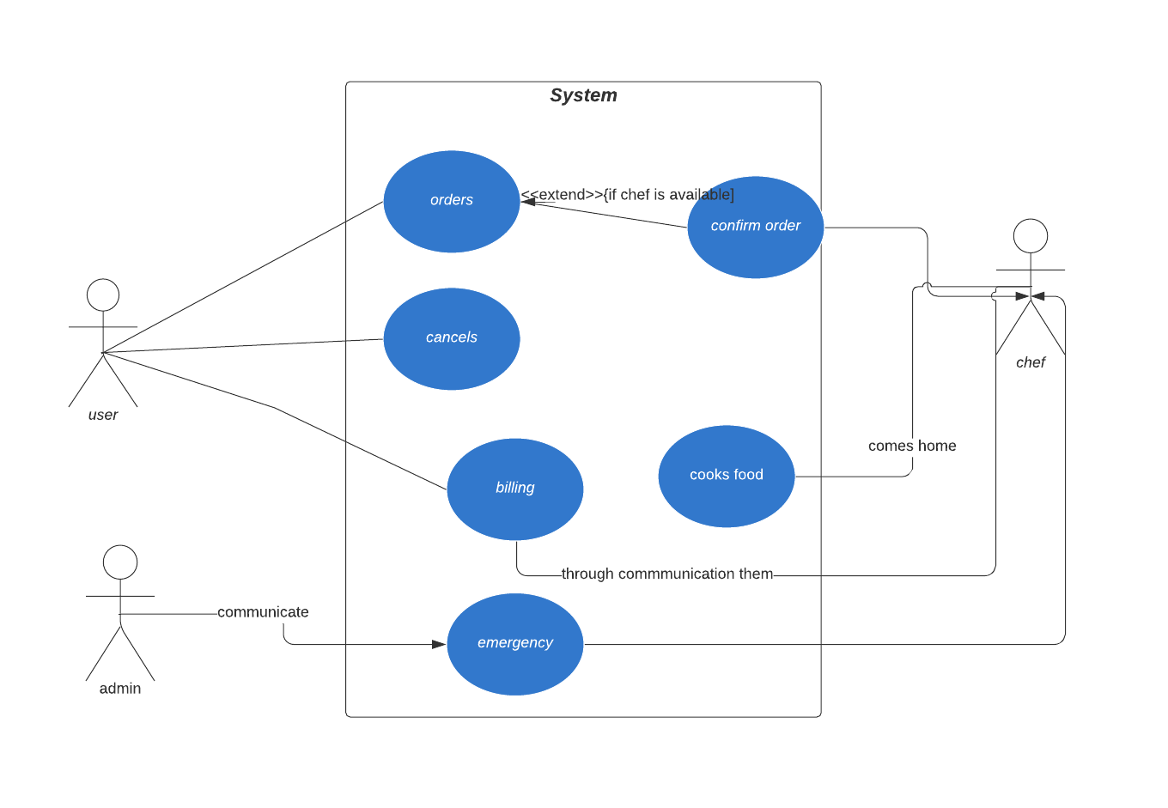

FIGURE 4.3.2: USE CASE DIAGRAM

4.3.3 SEQUENCE DIAGRAM:

Sequence diagram are used to represent the flow of messages, events and actions between the objects or components of a system. Time is represented in the vertical direction showing the sequence of interactions of the header elements, which are displayed horizontally at the top of the diagram.

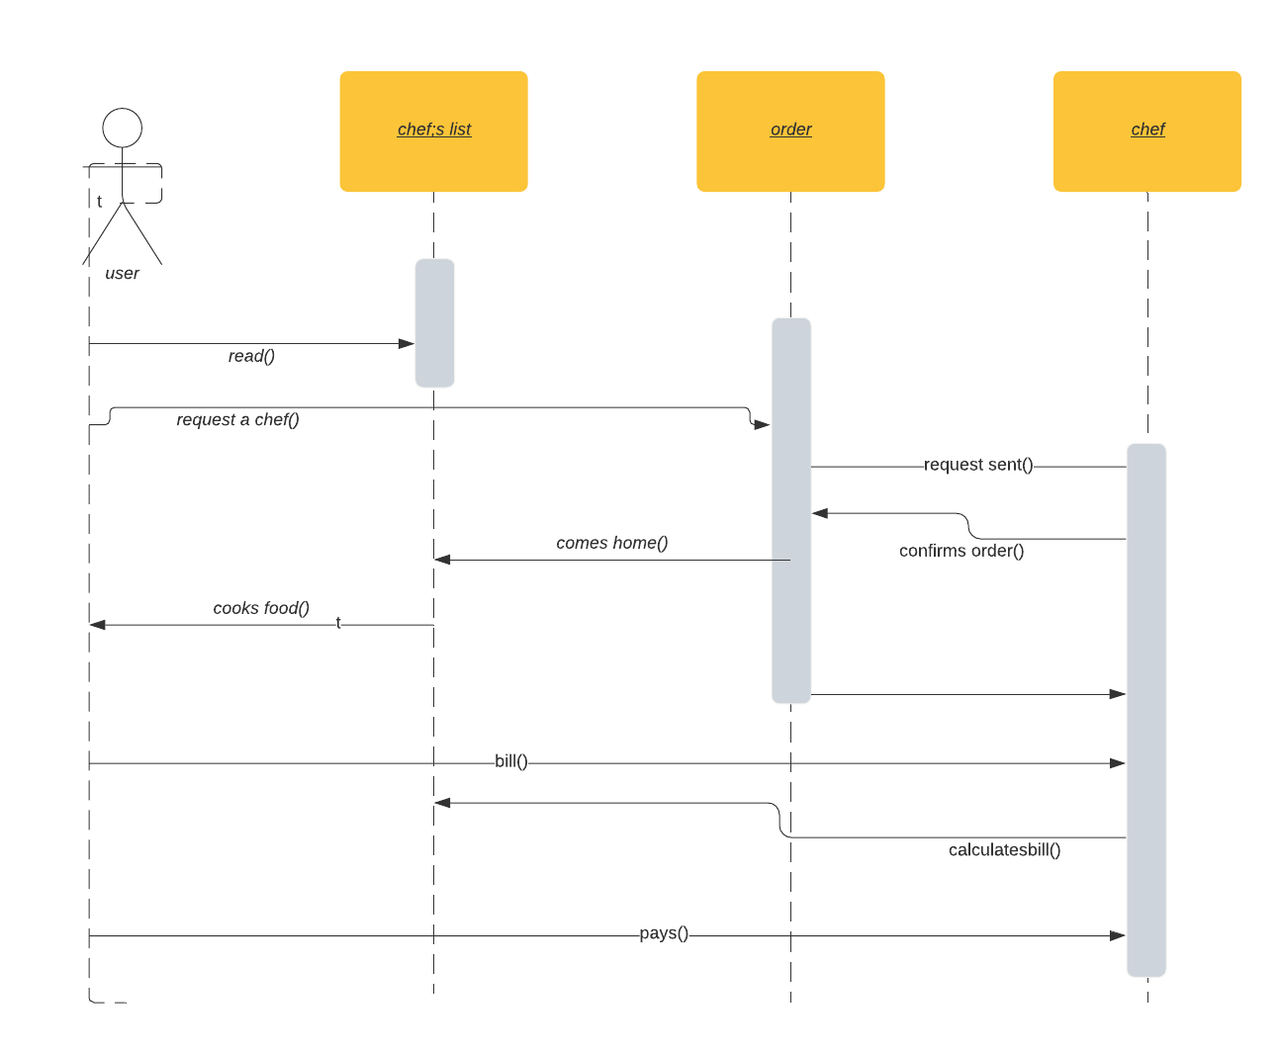

FIGURE 4.3.3: SEQUENCE DIAGRAM

4.3.4 ACTIVITY DIAGRAM:

Activity diagram represent the business and operational workflows of a system. An Activity diagram is a dynamic diagram that shows the activity and the event that causes the object to be in the particular state.
So, what is the importance of an Activity diagram, as opposed to a State diagram? A State diagram shows the different states an object is in during the life-cycle of its existence in the system, and the transitions in the states of the objects. These transitions depict the activities causing these transitions, shown by arrows.
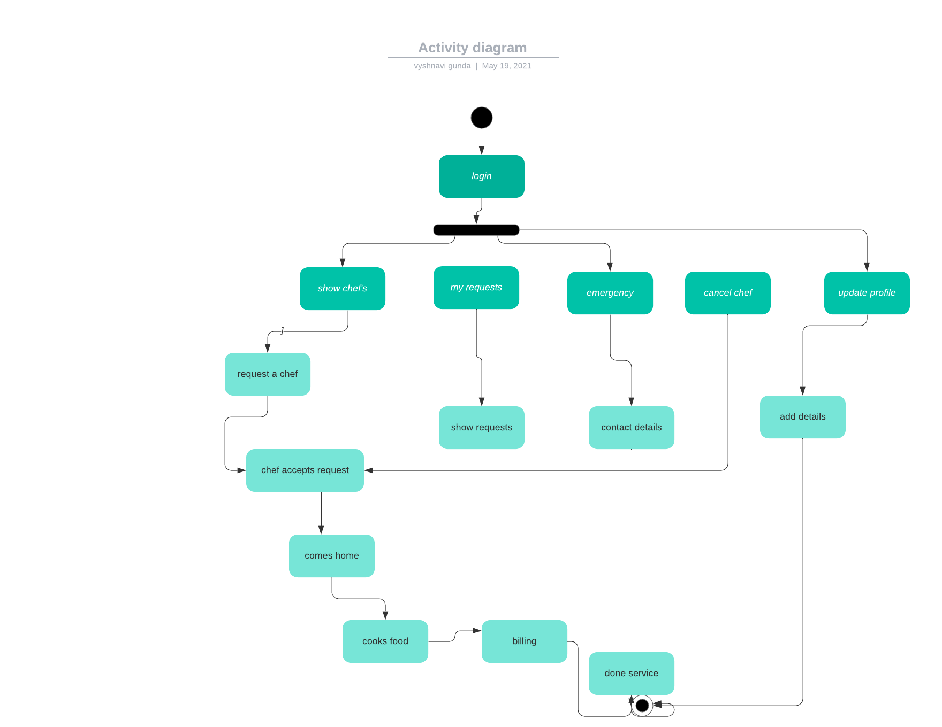

FIGURE 4.3.4: ACTIVITY DIAGRAM

4.3.5 DEPLOYMENT DIAGRAM:
Deployment diagrams are used to visualize the topology of the physical components of a system where the software components are deployed. So deployment diagrams are used to describe the static deployment view of a system. Deployment diagrams consist of nodes and their relationships.
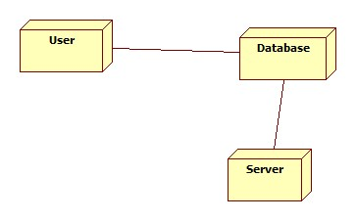
FIGURE 4.3.5: DEPLOYMENT DIAGRAM

5. IMPLEMENTATION
5.1 home.ejs:

<!DOCTYPE html>
<html lang="en">
<head>
<meta charset="UTF-8">
<meta http-equiv="X-UA-Compatible" content="IE=edge">
<meta name="viewport" content="width=device-width, initial-scale=1.0">
<link rel="stylesheet" href="https://maxcdn.bootstrapcdn.com/bootstrap/4.3.1/css/bootstrap.min.css">
<link rel="stylesheet" href="/stylesheets/img.css">
<title>home page</title>
</head>
<body>
<div class="container">
<% if (error && error.length > 0) {%>
<br>
<div class="alert alert-danger text-center" role="alert">
<%= error %>
</div>
<% } %>
<% if (success && success.length > 0) {%>
<br>
<div class="alert alert-success text-center" role="alert">
<%= success %>
</div>
<% } %>
</div>
<h1 style="margin-left: 100px; margin-top: 100px;"><b>Culinary Artist</b></h1>
<div style="margin-top: 50px; margin-left: 100px;">
<button class="btn-primary rounded btn" onclick="location.href='/chef_signin'">Chef SignIn</button><br /><br />
<button class="btn-primary rounded btn" onclick="location.href='/signin'">SignIn</button><br /><br />
<button class="btn-primary rounded btn" onclick="location.href='/signup'">SignUp</button><br /><br />
<!-- <a href='/signin'>SignIn</a><br><br />
<a href='/signup'>SignUp</a><br /> -->
</div>
</body>
</html>

5.2 app.js:

require('dotenv').config();
var createError = require('http-errors');
var express = require('express');
var path = require('path');
var cookieParser = require('cookie-parser');
var logger = require('morgan');
var session = require('express-session');
var flash = require('connect-flash');
var bodyParser = require('body-parser');
var MongoDBStore = require('connect-mongodb-session')(session);
var moment = require('moment');

var indexRouter = require('./routes/index');
var usersRouter = require('./routes/users');

// Sessions
var sessionStore = new MongoDBStore({
uri: 'mongodb://localhost/mp',
collection: 'sessions'
});
sessionStore.on('error', function(error) {
// Also get an error here
console.log(error);
});
var app = express();
// view engine setup
app.set('views', path.join(__dirname, 'views'));
app.set('view engine', 'ejs');
app.use(logger('dev'));
app.use(express.json());
app.use(express.urlencoded({ extended: false }));
app.use(cookieParser());
app.use(express.static(path.join(__dirname, 'public')));
app.use(bodyParser.urlencoded({extended: false}));
app.use(flash());
app.locals.moment = moment;
app.use(cookieParser());
app.use(session({
secret: process.env.COOKIE_SCERET,
resave: true,
store: sessionStore,
saveUninitialized: true,
cookie:{ maxAge: 1000 * 60 * 60 * 24 } // 24 hrs
}));
app.use('/', indexRouter);
app.use('/users', usersRouter);
// catch 404 and forward to error handler
app.use(function(req, res, next) {
next(createError(404));
});
// error handler
app.use(function(err, req, res, next) {
// set locals, only providing error in development
res.locals.message = err.message;
res.locals.error = req.app.get('env') === 'development' ? err : {};
// render the error page
res.status(err.status || 500);
res.render('error');
});
const PORT = process.env.PORT || 5000 ;
app.listen(PORT, function () {
console.log(`The Server Has Started! at port ${PORT}`);
});

module.exports = app;

6. TESTING
Software testing is a critical element of software quality assurance and represents the ultimate review of specification, design and code generation.
6.1 TESTING OBJECTIVES:

- To ensure that during operation the system will perform as per specification.
- To make sure that system meets the user requirements during operation
- To make sure that during the operation, incorrect input, processing and output will be detected
- To see that when correct inputs are fed to the system the outputs are correct
- To verify that the controls incorporated in the same system as intended
- Testing is a process of executing a program with the intent of finding an error
- A good test case is one that has a high probability of finding an as yet undiscovered error

The software developed has been tested successfully using the following testing strategies and any errors that are encountered are corrected and again the part of the program or the procedure or function is put to testing until all the errors are removed. A successful test is one that uncovers an as yet undiscovered error.

Note that the result of the system testing will prove that the system is working correctly. It will give confidence to system designer, users of the system, prevent frustration during implementation process etc.

6.2 TESTING METHODOLOGIES:
- White box testing.
- Black box testing.
- Unit testing.
- Integration testing.
- User acceptance testing.
- Output testing.
- Validation testing.
- System testing.
- Unit Testing:

Unit testing focuses verification effort on the smallest unit of Software design that is the module. Unit testing exercises specific paths in a module’s control structure to ensure complete coverage and maximum error detection. This test focuses on each module individually, ensuring that it functions properly as a unit. Hence, the naming is Unit Testing.

- Integration Testing:

Integration testing addresses the issues associated with the dual problems of verification and program construction. After the software has been integrated a set of high order tests are conducted. The main objective in this testing process is to take unit tested modules and builds a program structure that has been dictated by design.

The following are the types of Integration Testing:

- Top Down Integration:

This method is an incremental approach to the construction of program structure. Modules are integrated by moving downward through the control hierarchy, beginning with the main program module.

- Bottom Up Integration:

This method begins the construction and testing with the modules at the lowest level in the program structure. Since the modules are integrated from the bottom up, processing required for modules subordinate to a given level is always available and the need for stubs is eliminated.

- User acceptance Testing:

User Acceptance of a system is the key factor for the success of any system. The system under consideration is tested for user acceptance by constantly keeping in touch with the prospective system users at the time of developing and making changes wherever required. The system developed provides a friendly user interface that can easily be understood even by a person who is new to the system.

- Output Testing:

After performing the validation testing, the next step is output testing of the proposed system, since no system could be useful if it does not produce the required output in the specified format. Asking the users about the format required by them tests the outputs generated or displayed by the system under consideration. Hence the output format is considered in 2 ways – one is on screen and another in printed format.

- Validation Testing:

Validation testing is generally performed on the following fields:

- Text Field:
The text field can contain only the number of characters lesser than or equal to its size. The text fields are alphanumeric in some tables and alphabetic in other tables. Incorrect entry always flashes and error message.

\
- Numeric Field:
The numeric field can contain only numbers from 0 to 9. An entry of any character flashes an error messages. The individual modules are checked for accuracy and what it has to perform.

- Preparation of Test Data:

Taking various kinds of test data does the above testing. Preparation of test data plays a vital role in the system testing. After preparing the test data the system under study is tested using that test data. While testing the system by using test data errors are again uncovered and corrected by using above testing steps and corrections are also noted for future use.

6.3 USER TRAINING:

Whenever a new system is developed, user training is required to educate them about the working of the system so that it can be put to efficient use by those for whom the system has been primarily designed. For this purpose, the normal working of the project was demonstrated to the prospective users. Its working is easily understandable and since the expected users are people who have good knowledge of computers, the use of this system is very easy.

6.4 MAINTAINENCE:

This covers a wide range of activities including correcting code and design errors. To reduce the need for maintenance in the long run, we have more accurately defined the user’s requirements during the process of system development. Depending on the requirements, this system has been developed to satisfy the needs to the largest possible extent. With development in technology, it may be possible to add many more features based on the requirements in future. The coding and designing is simple and easy to understand which will make maintenance easier.

6.5 TESTING STRATEGY:

A strategy for system testing integrates system test cases and design techniques into a well-planned series of steps that results in the successful construction of software. The testing strategy must co-operate test planning, test case design, test execution, and the resultant data collection and evaluation. A strategy for software testing must accommodate low-level tests that are necessary to verify that a small source code segment has been correctly implemented as well as high level tests that validate major system functions against user requirements.

Software testing is a critical element of software quality assurance and represents the ultimate review of specification design and coding.

6.5.1 SYSTEM TESTING:

Software once validated must be combined with other system elements (e.g. Hardware, people, database). System testing verifies that all the elements are proper and that overall system function performance is achieved. It also tests to find discrepancies between the system and its original objective, current specifications and system documentation.

6.5.2 UNIT TESTING:

In unit testing different are modules are tested against the specifications produced during the design for the modules. Unit testing is essential for verification of the code produced during the coding phase, and hence the goals to test the internal logic of the modules. Using the detailed design description as a guide, important Conrail paths are tested to uncover errors within the boundary of the modules. This testing is carried out during the programming stage itself. In this type of testing step, each module was found to be working satisfactorily as regards to the expected output from the module. In Due Course, latest technology advancements will be taken into consideration. As part of technical build-up many components of the networking system will be generic in nature so that future projects can either use or interact with this.

6.6 TEST CASES:

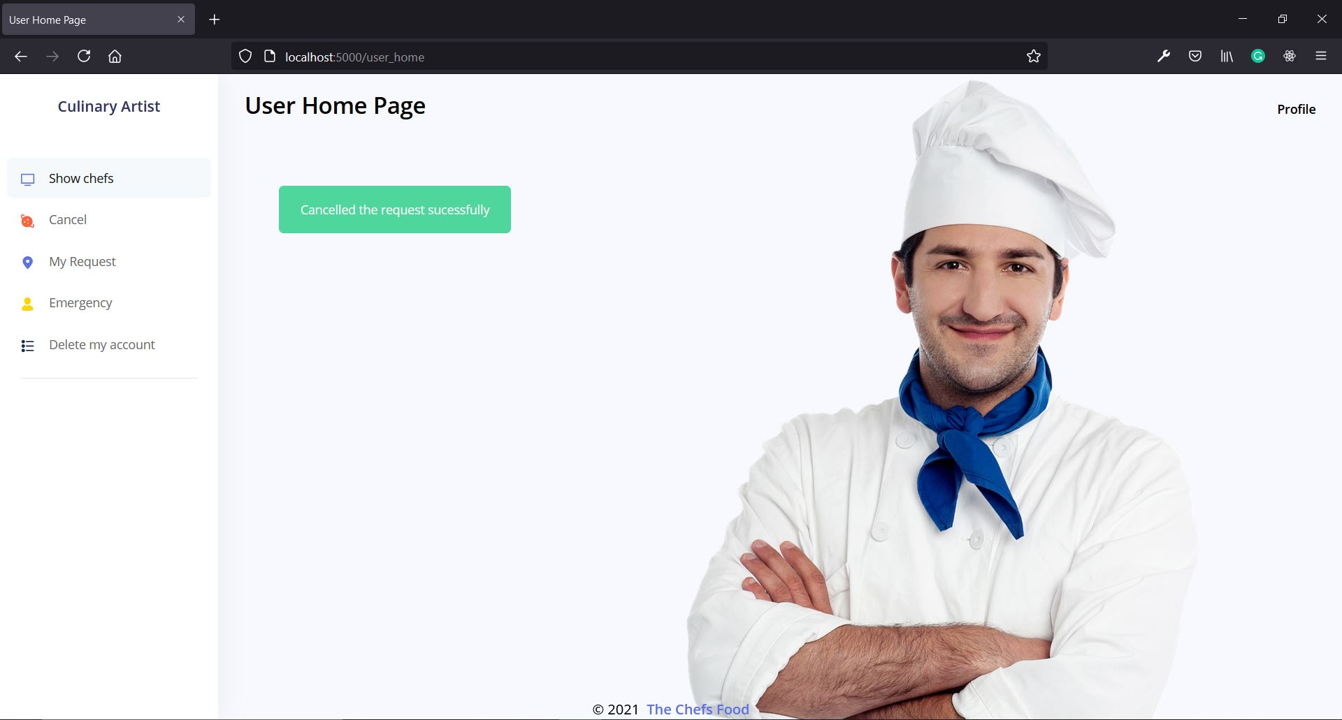

Figure: 6.6.1 Cancel the ordered chef

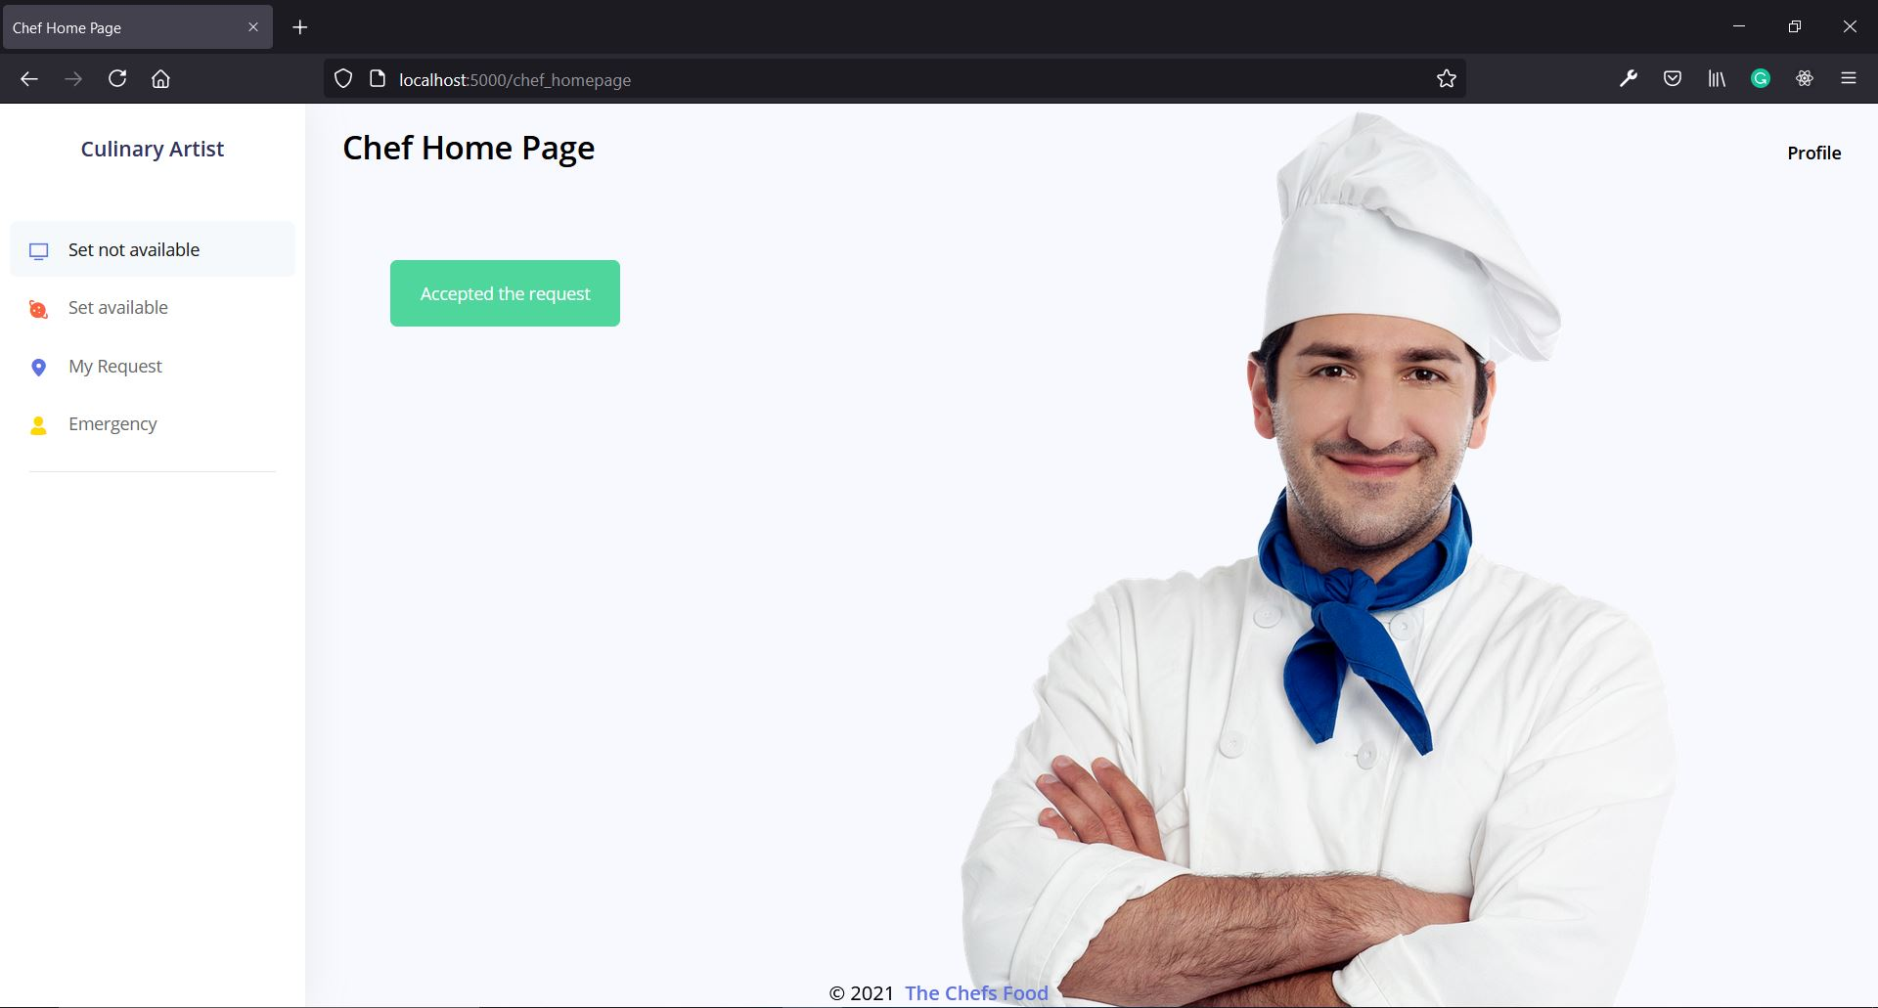

Figure: 6.6.2 Accept the user request
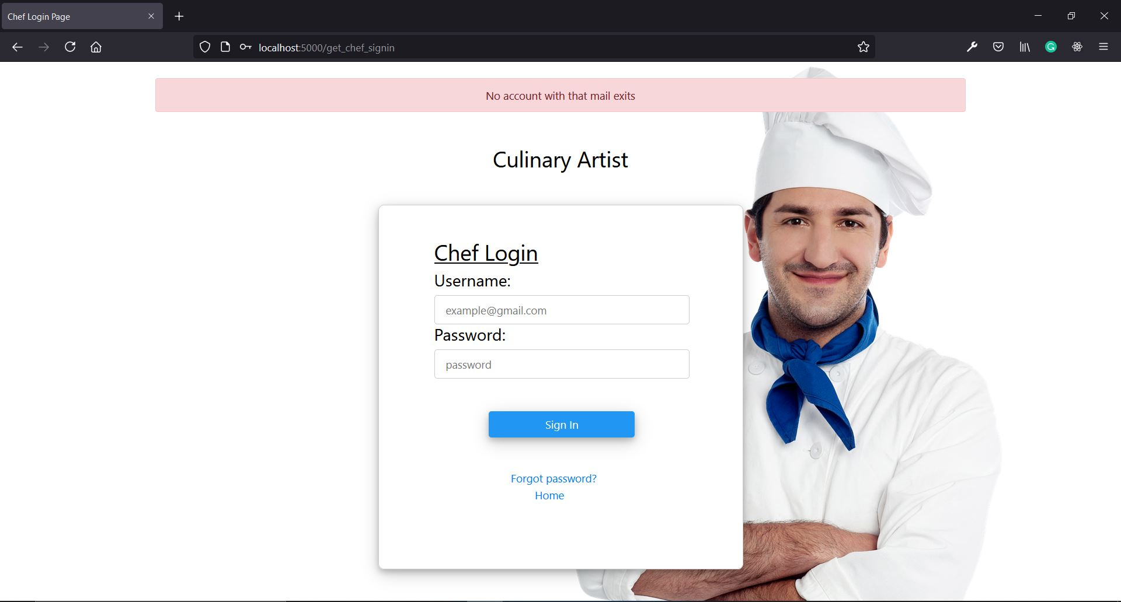

Figure: 6.6.3 Invalid Email
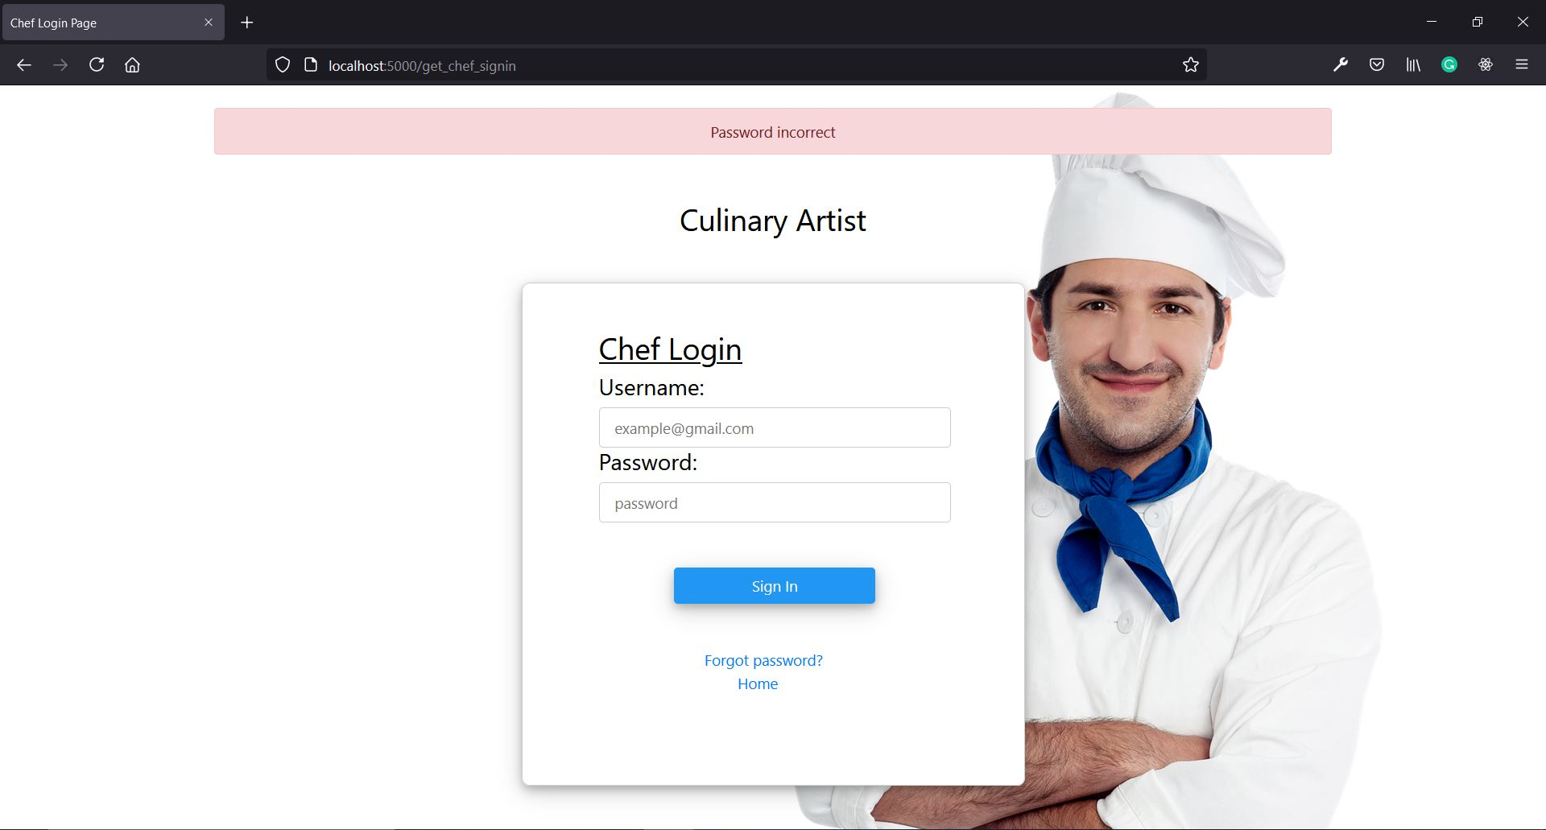

Figure: 6.6.4 Incorrect password
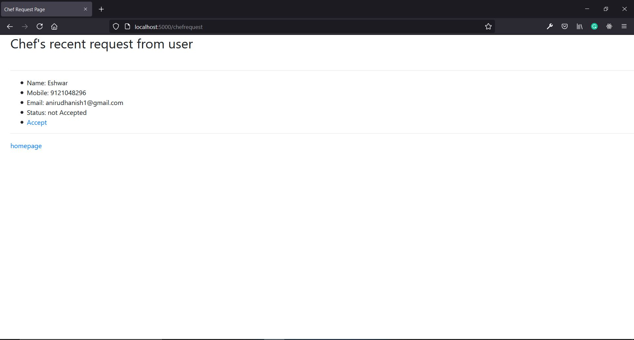

Figure:6.6.5 Chef request page
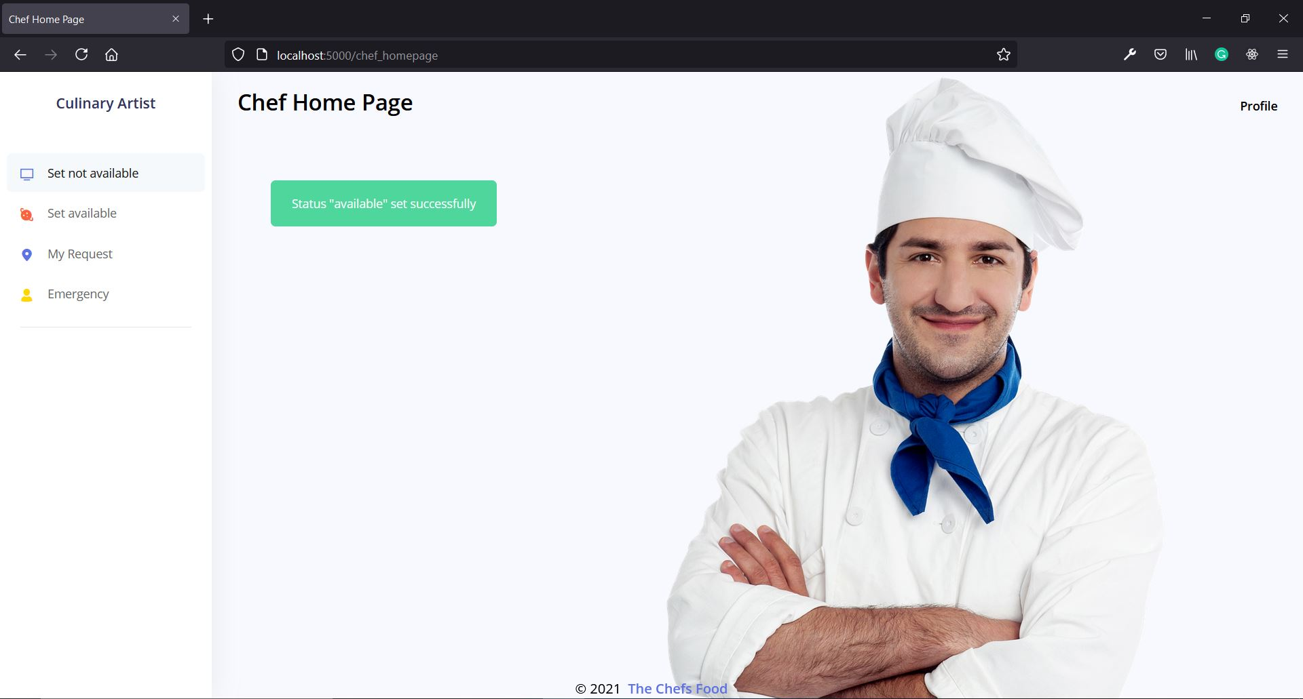

Figure: 6.6.6 Chef set available
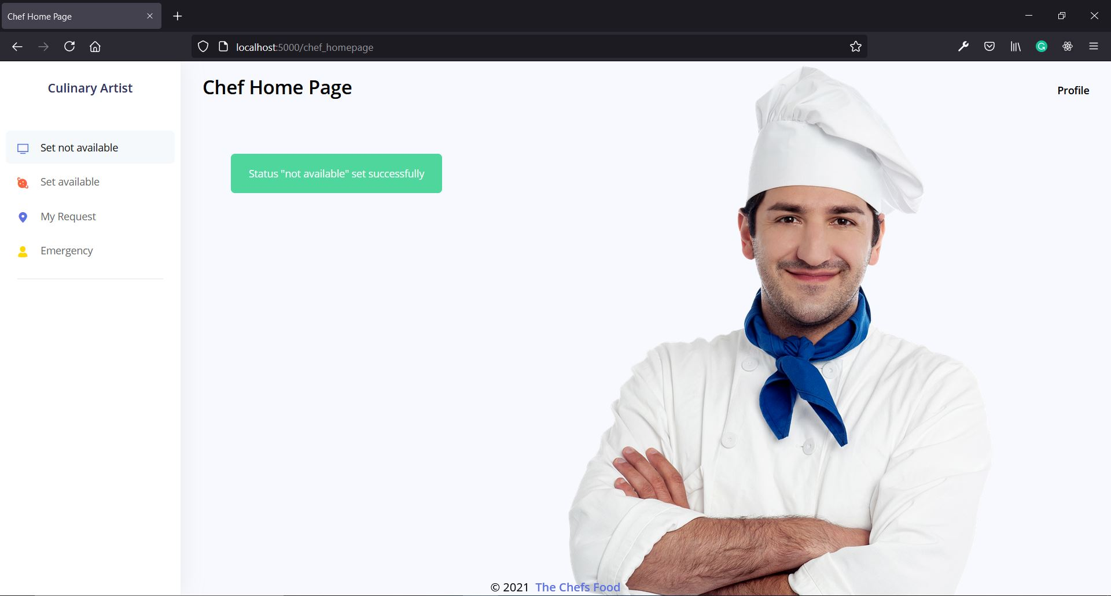

Figure: 6.6.7 Chef set not available
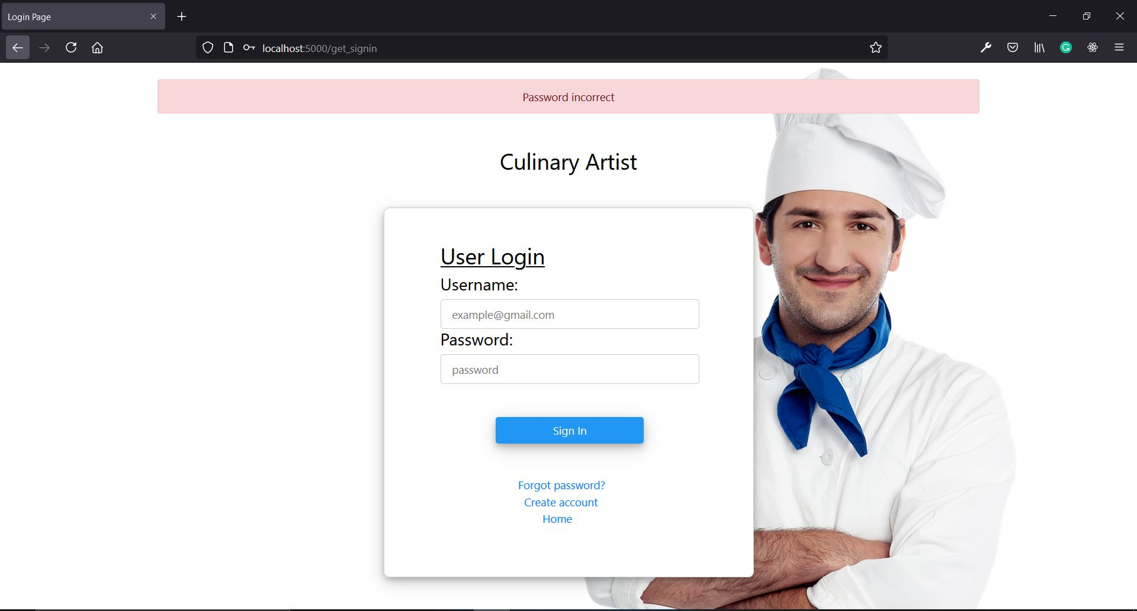

Figure: 6.6.8 Incorrect Password
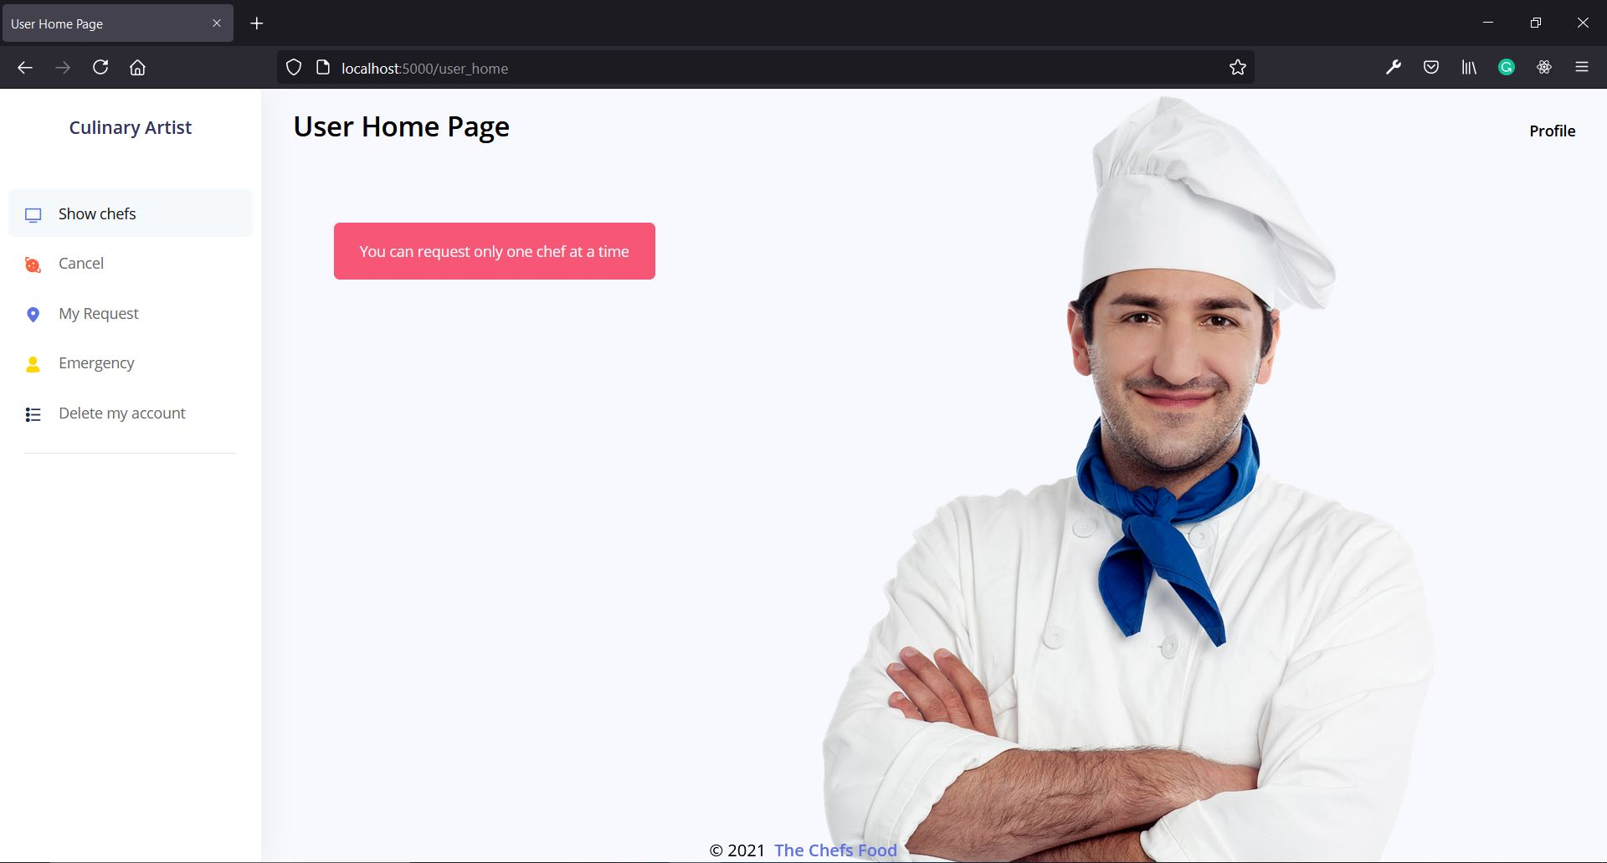

Figure: 6.6.9 Only one chef can be booked
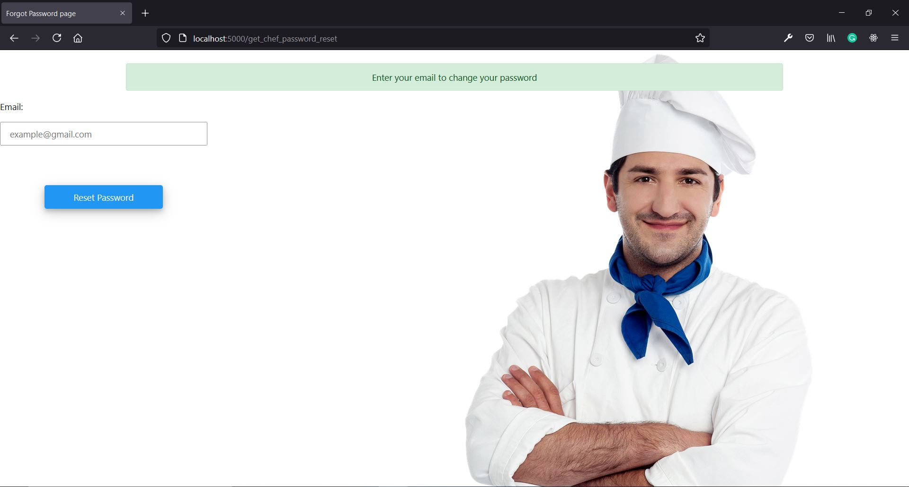

Figure: 6.6.10 Password reset
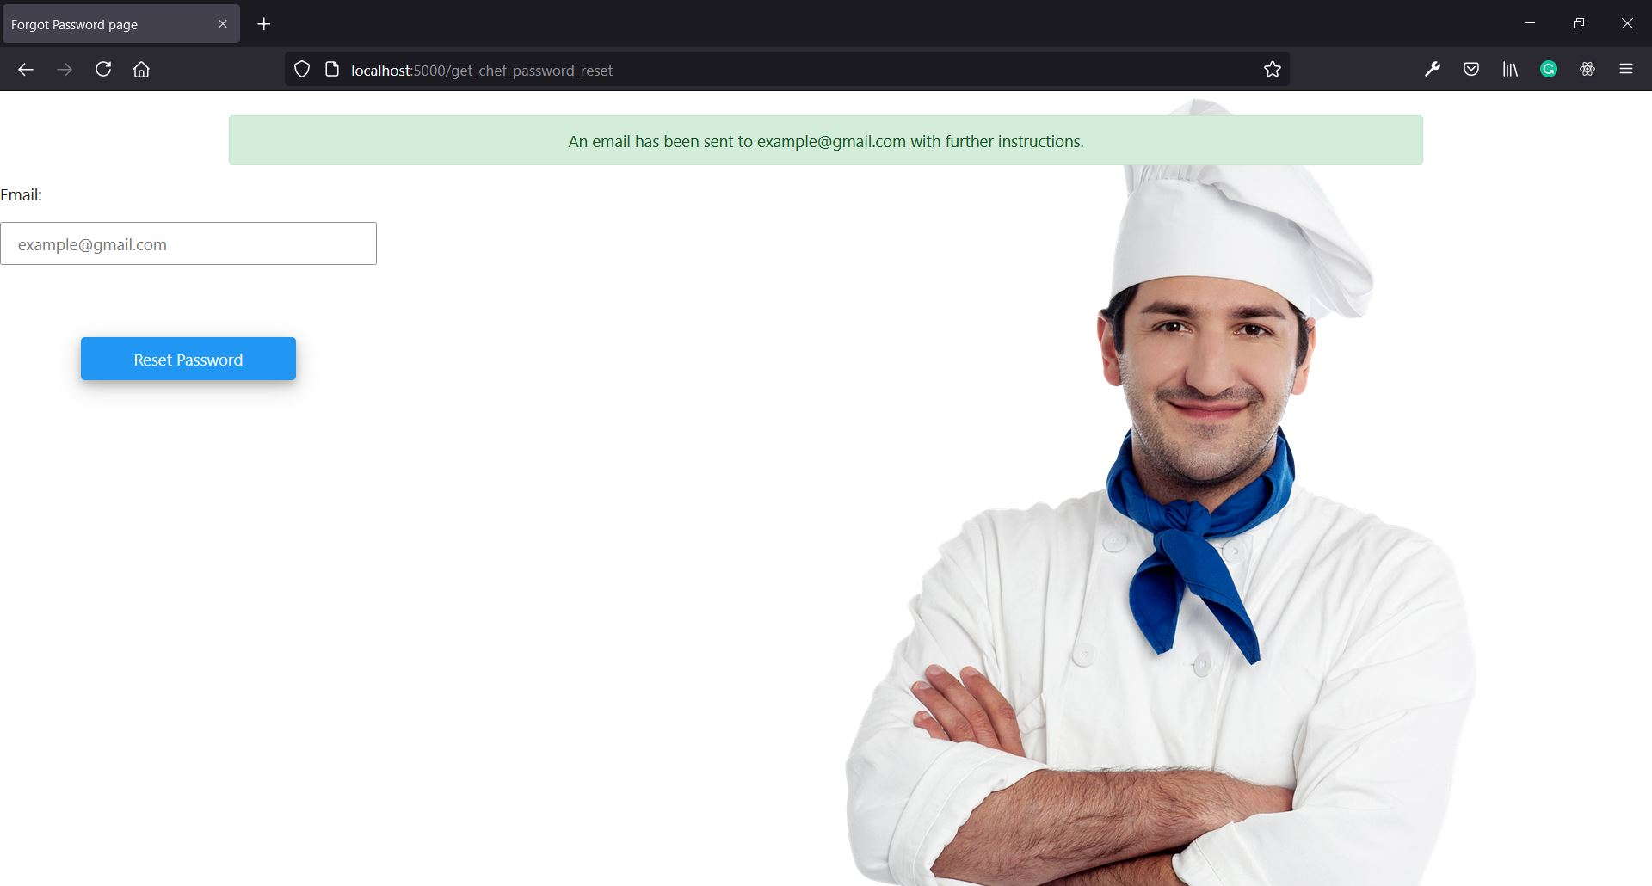

Figure: 6.6.11 Password reset email
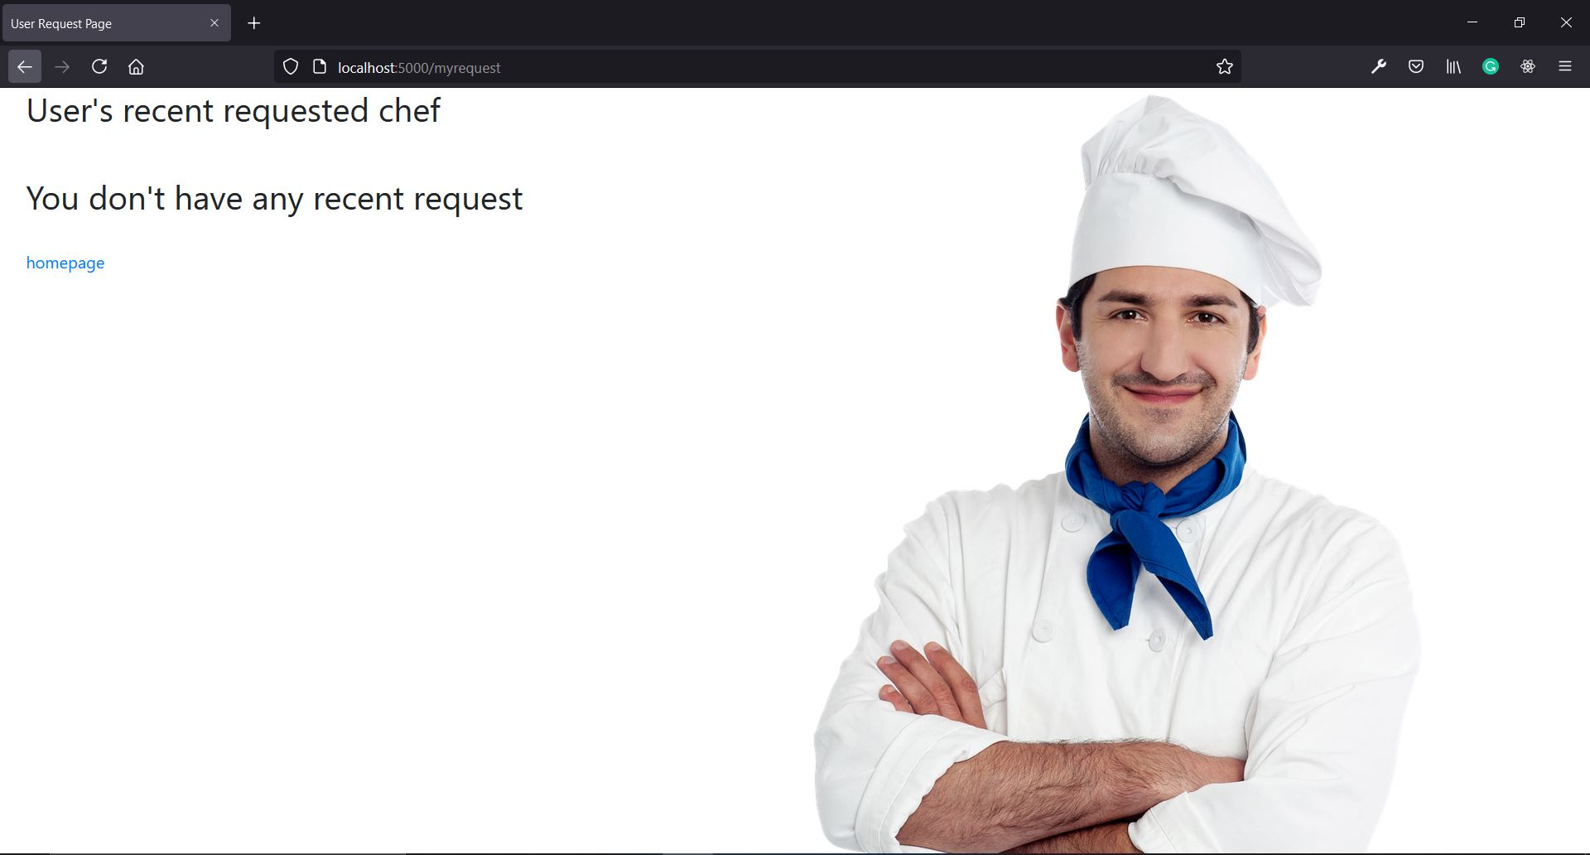

Figure: 6.6.12 No user requests
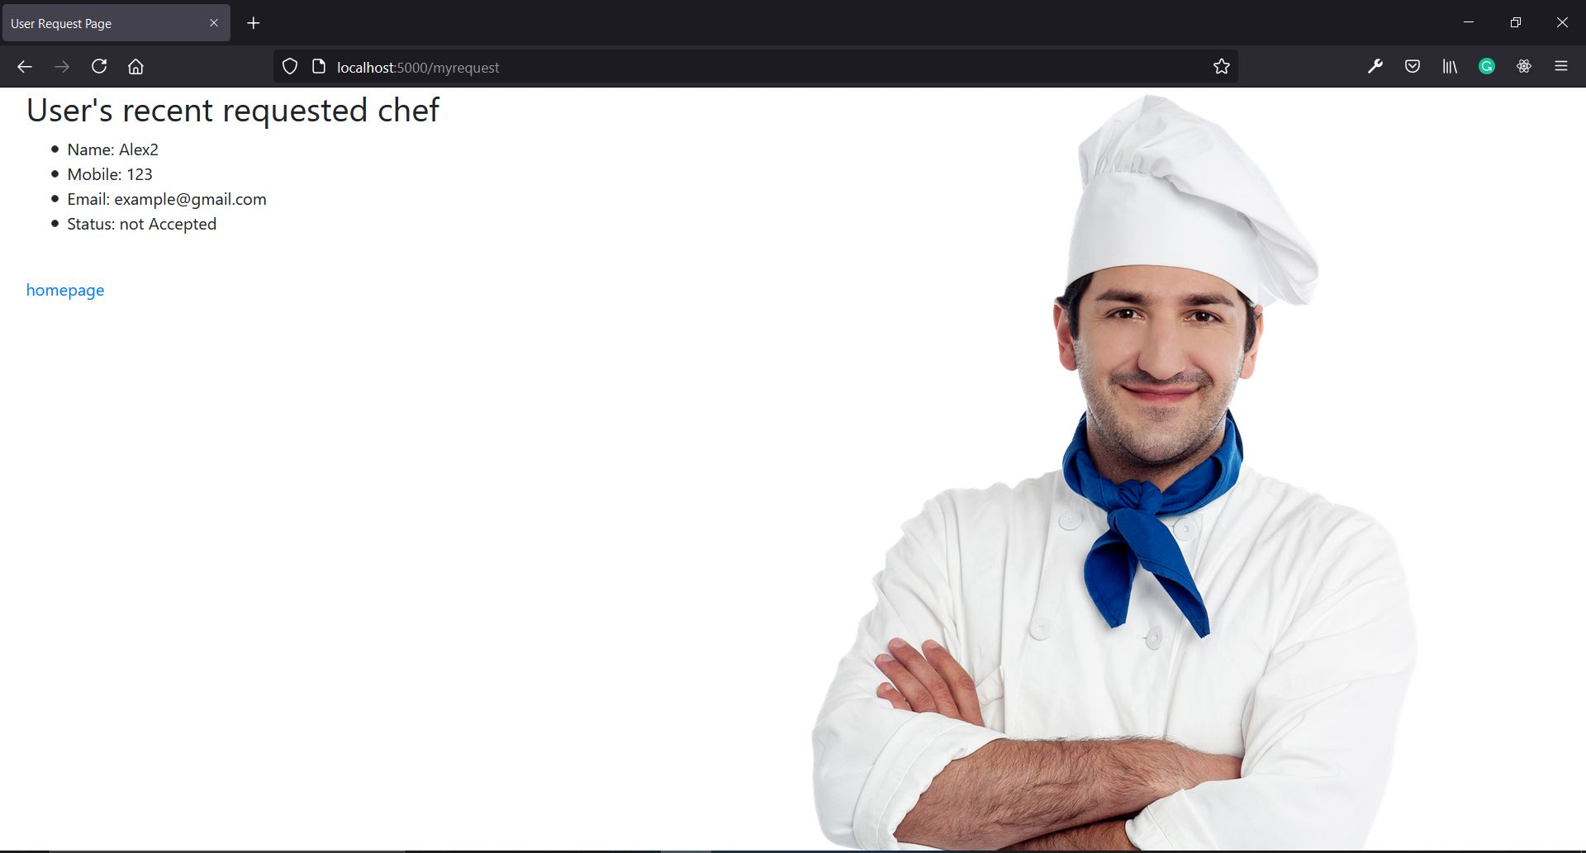

Figure: 6.6.13 User request status not accepted
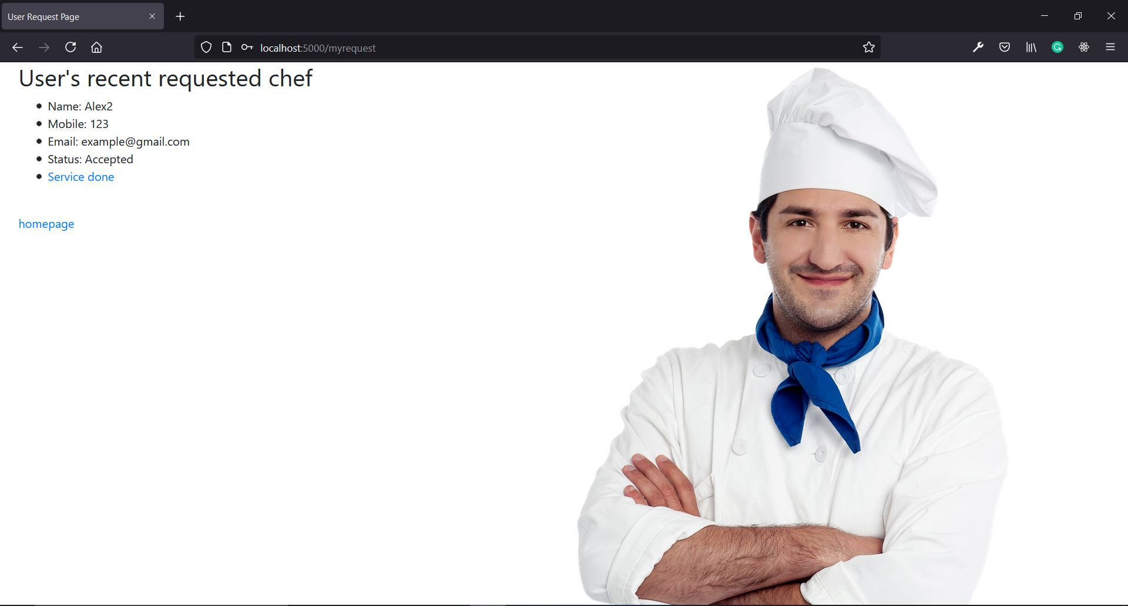

Figure: 6.6.14 User request status accepted
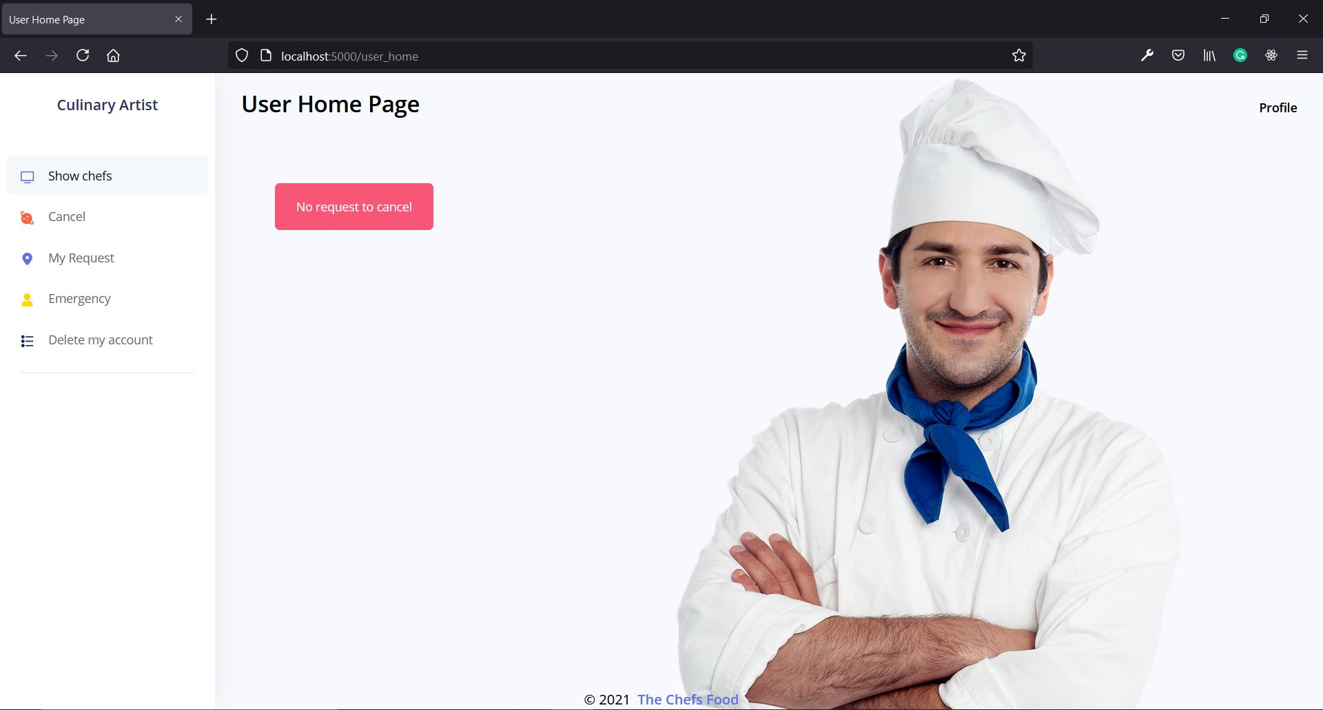

Figure: 6.6.15 No request to cancel
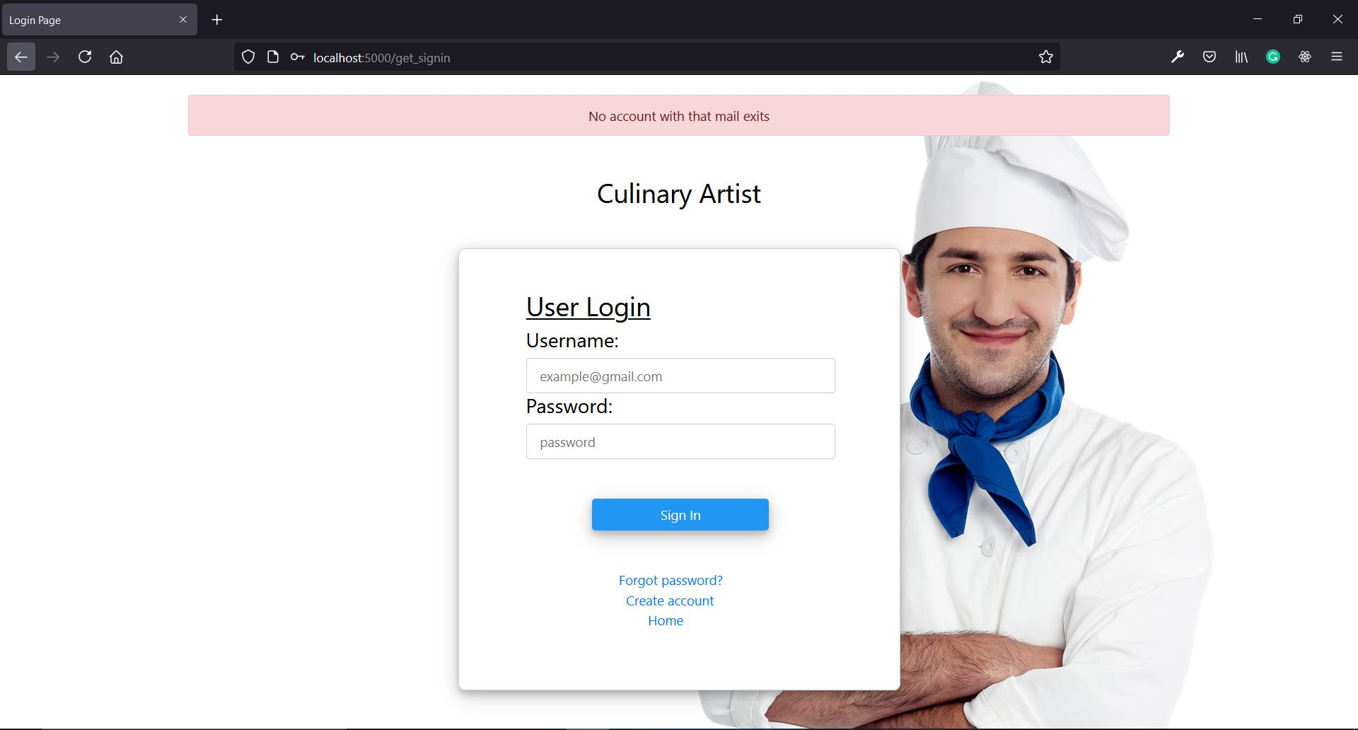

Figure: 6.6.16 Incorrect Email

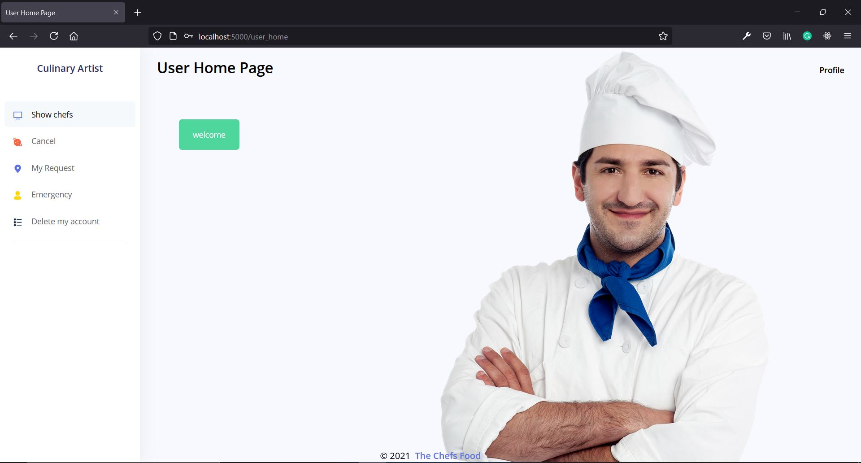

Figure: 6.6.17 User homepage

7. OUTPUT SCREENS

7.1 Home Screen:

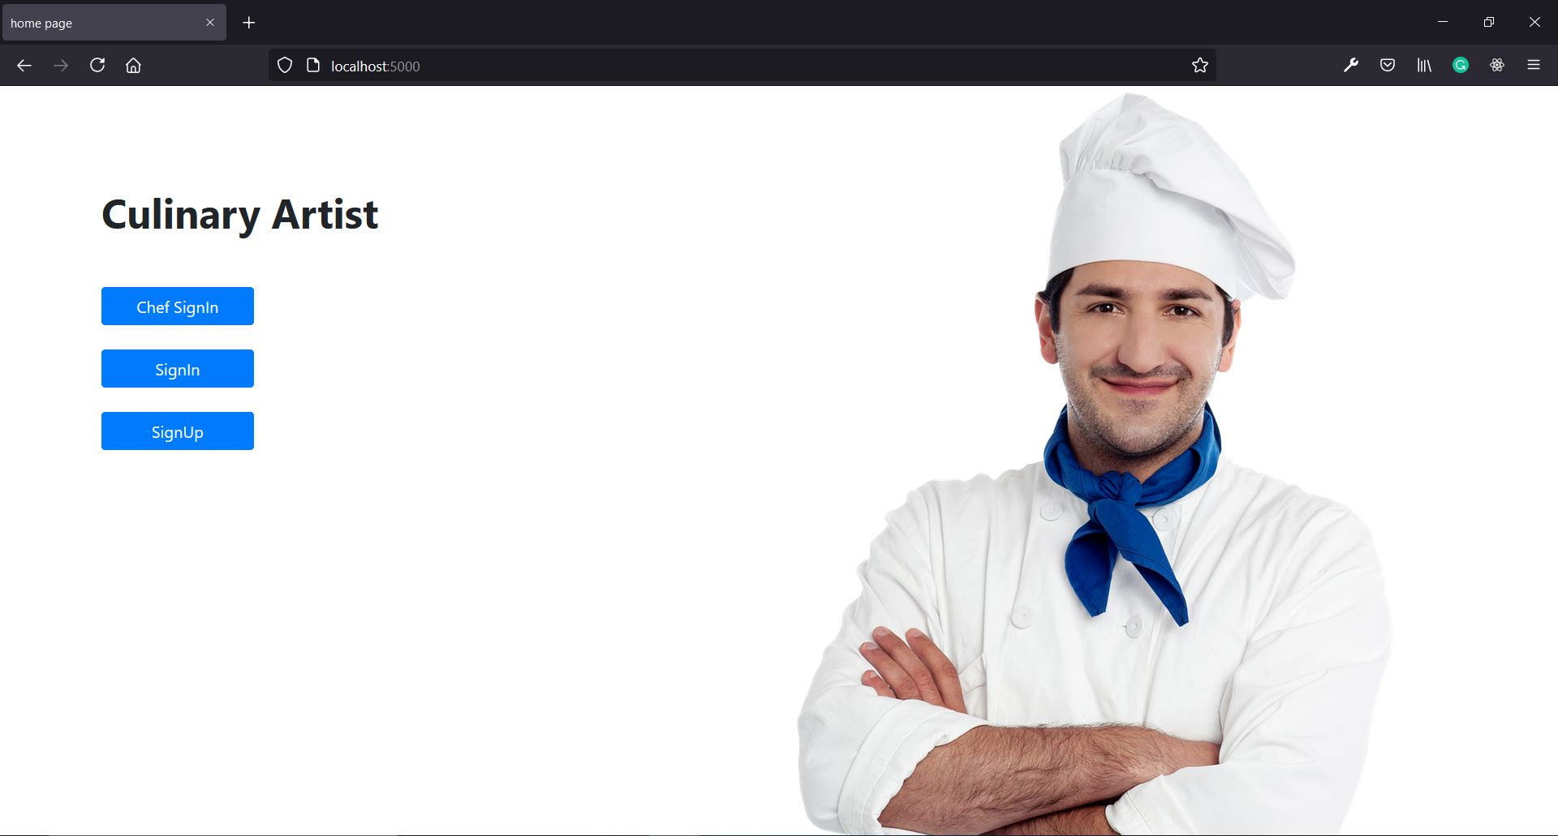

7.2 User Login Page:

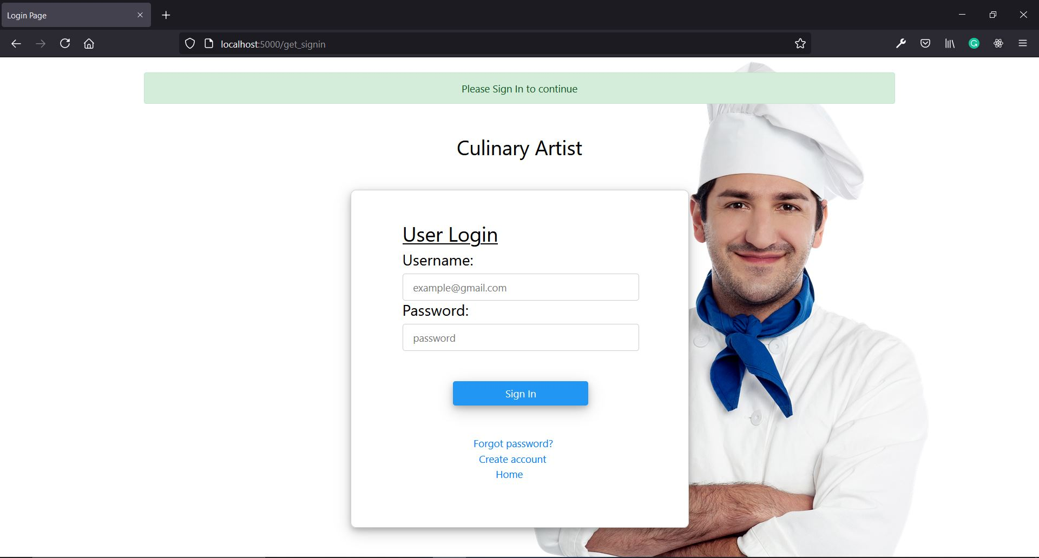

7.3 User Registration Page:

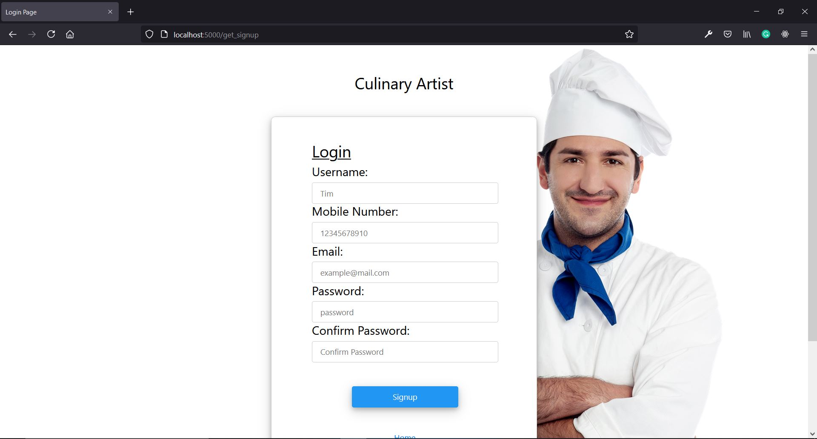

7.4 Chef Login Page:

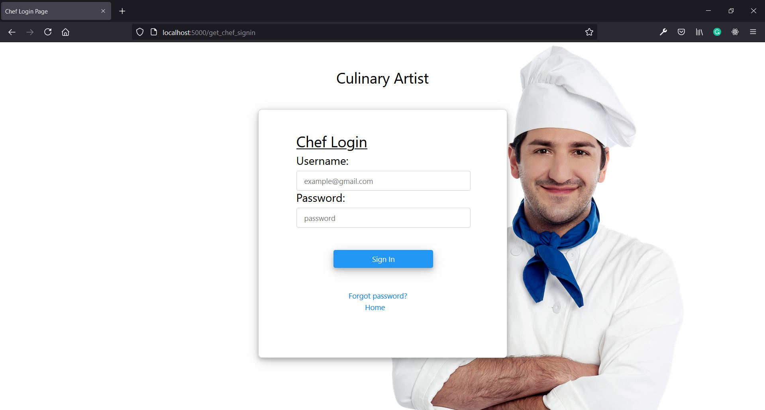

7.5 User Home Page:

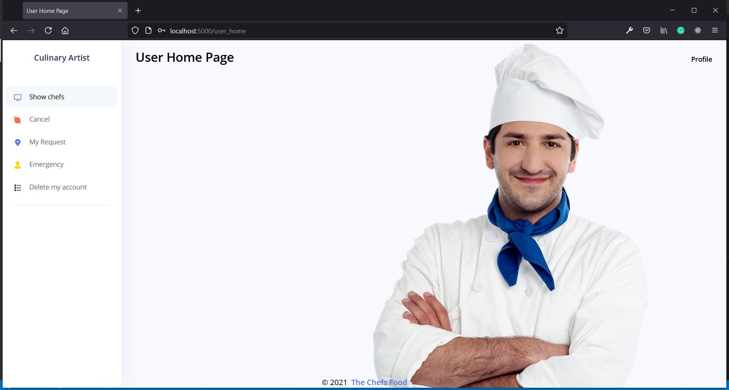

7.6 List of Chefs:

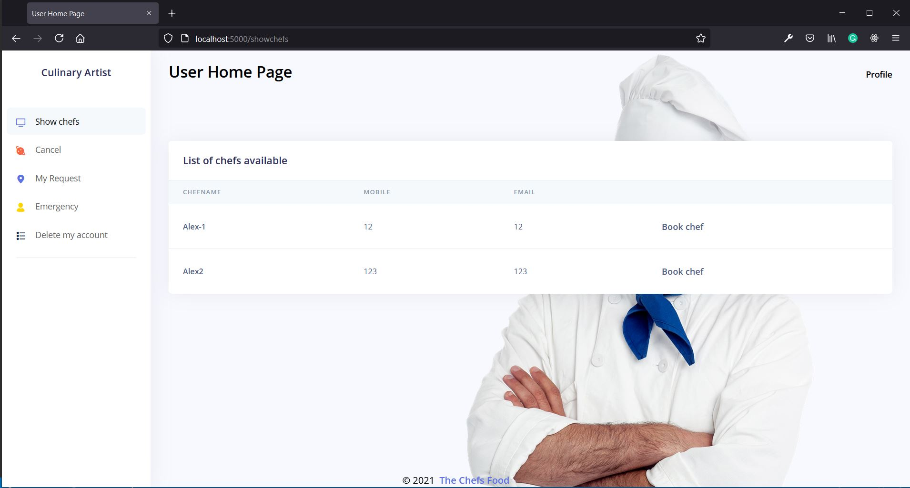

7.7 Admin Home Page:

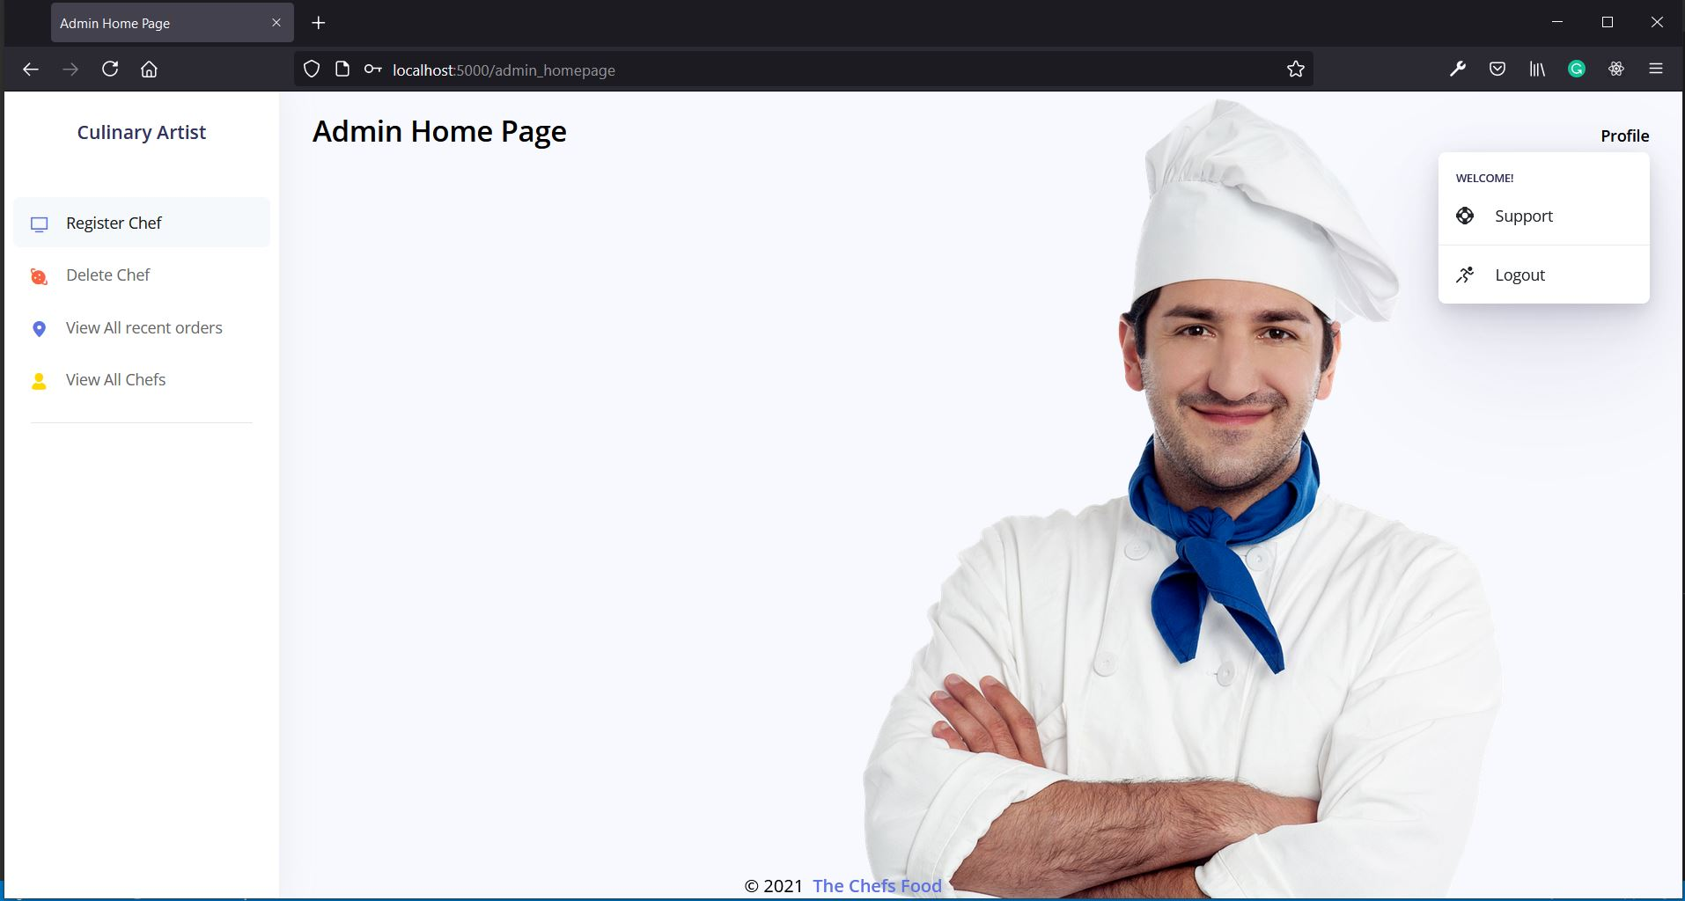

7.8 Chef Home Page:

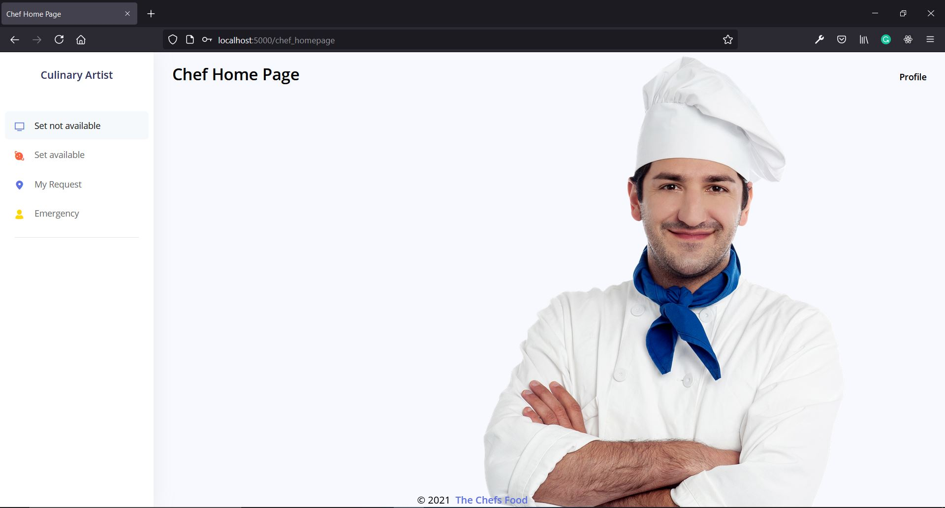

8. CONCLUSION & FUTURE SCOPE

8.1 CONCLUSION:

- Thus, by using our chef’s food we tried to increase the hygiene of our food which is essential in present days.
- We can experience the hospitality of a chef at the comfort of your home.

8.2 FUTURE SCOPE:
- In future we would like to add some more functionality where chef can chat with the chef.
- We would like to add the chef booking options like for hourly-basis or for whole day.

9. BIBLIOGRAPHY

REFERENCES:
- Software Engineering A practitioner’s Approach, Roger S Pressman, 6th edition. McGrawHillInternationalEdition.
- Software Engineering, Ian Sommerville, 7th edition, Pearsoneducation.
- bcrypt
https://github.com/kelektiv/node.bcrypt.js#readme
- bootstrap
https://getbootstrap.com/docs/5.0/getting-started/introduction/
- mongoose
https://mongoosejs.com/docs/guide.html
- nodemailer
https://github.com/nodemailer/nodemailer/

